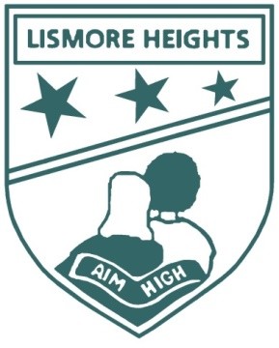  Lismore Heights Public School | 9 & 10 June  2016  Parent Report
MC Education Consultancy was invited by the Principal to complete an external, independent ‘Health Check’ at Lismore Heights Public School |  | Collegial ‘Health Check’ of Aboriginal and Torres Strait Islander Education

Evaluation of Aboriginal and Torres Strait Islander Education

Contents

1.00 ‘Health Check’ Purpose

2.00 Acknowledgement and Terminology

3.00 Team members and Interviewee Data

4.00 School Information from Data Review

5.00 Commendations

6.00 Recommendations
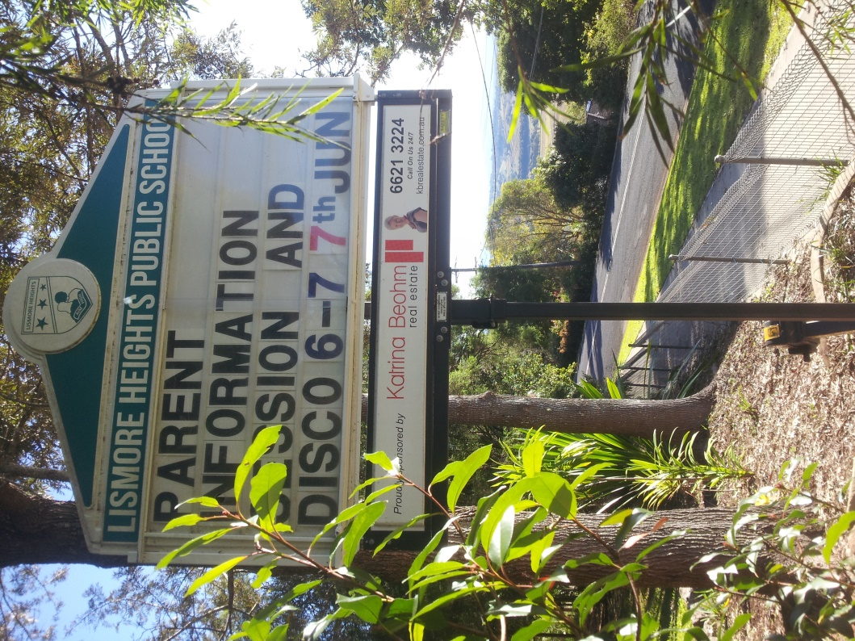
7.00 Areas for Further Consideration

8.00 Additional Resources

Lismore Heights Public School

1.00 Purpose

MC Education Consultancy was invited by Lismore Heights Public School through its Principal to facilitate an evaluation of the school with a view to identifying the strengths and opportunities of the Aboriginal education programs, as well to offer any ideas, where appropriate, for the ongoing operation and sustainability of the Aboriginal education strategy.

2.00 Acknowledgement and Terminology

2.01
The School and ‘Health Check’ team acknowledge that the School is built upon the traditional lands of the Wijabul Wiyabal people of the Bundjalung Nation. We pay our respects to Elders past and present and ask for their guidance as we work towards improving outcomes for their descendants and other Aboriginal and Torres Strait students living on Bundjalung land.

2.01
The terms Aboriginal, Indigenous, Torres Strait Islander and Koori may be used in this document when quoting interviewees. In all contexts they are inclusive of both Aboriginal and Torres Strait Islander students and community members and also inclusive of those Aboriginal people from other language nations across Australia.

2.02
This report is a collation of comments made by individuals and interview groups. The report is for the school Principal. Some sensitive data may need to be removed before dissemination to other groups within the school and community. The interview team does not aim to validate/confirm/condone or challenge all comments, issues or concerns raised in the interviews as such. Therefore the Principal will receive a broad range of comments and feelings from interview groups and we acknowledge that not all of these have been validated but are included to provide the full breadth of opinion in interview groups.

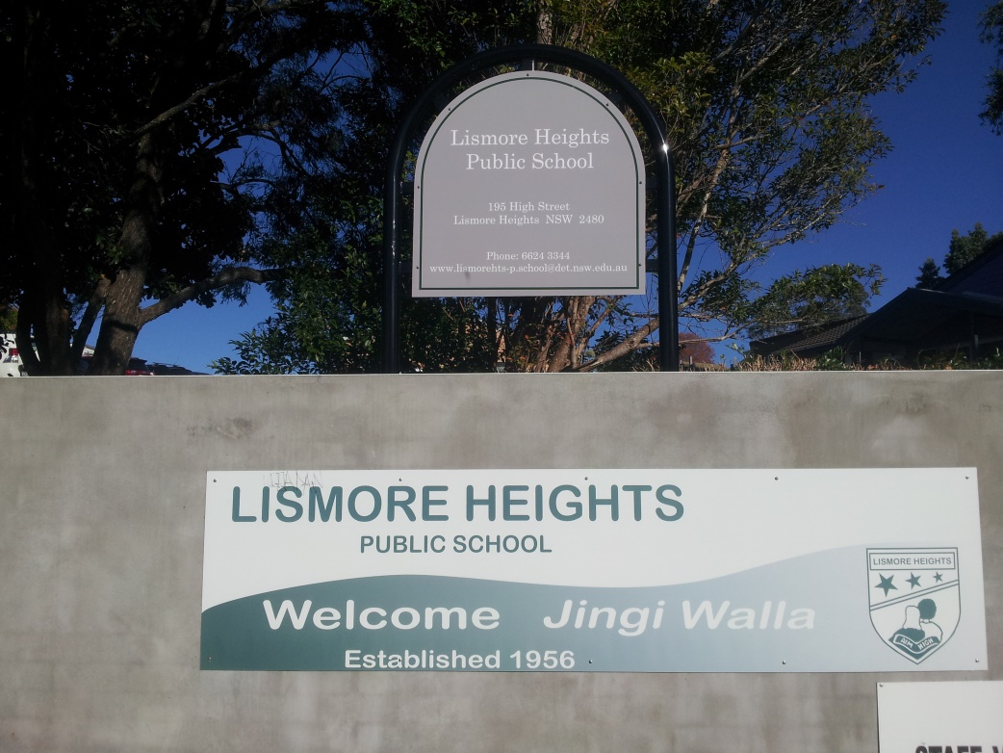

3.00 Team members and Interviewee Data

The review team consisted of Mark Crouch (MC Education Consultancy) and Martin Gill (Colleague Network Principal). Interviews were held with the following:

- Aboriginal and/or Torres Strait Islander students - 10
- Non-Aboriginal students - 5
- Classroom Teachers / Senior Executive Members / School Support Staff - 10
- Aboriginal and/or Torres Strait Islander employees - 2
- Aboriginal and/or Torres Strait Islander parents and community members - 4
- Non-Aboriginal and/or Torres Strait Islander parents and community members - 5

4.00 School Information

School Profile (MySchool Website)
Lismore Heights Public School is situated above the town of Lismore overlooking the picturesque hills to the north. Our beautiful school caters for students of all abilities from Kindergarten to Year 6. Presently, the school has eleven classrooms, two of which are Support Classes for students with additional needs. Approximately 230 students are currently enrolled at the school. 24% of our students are Aboriginal. All of our students make an outstanding contribution to the life and culture of our happy school. The school and its community work hand in hand to ensure that all of our students 'Aim High' and reach their full potential.

The teachers and support staff at Lismore Heights Public School share a passion for learning, and this radiates outwards into our daily teaching. As a result, our children encounter a range of stimulating and exciting learning opportunities which extend beyond the basics. Performing & Creative Arts and Sport feature heavily in our teaching and learning programmes, as does our commitment to celebrating key events in the Australian calendar such as, ANZAC day and NAIDOC Week.

Students' progress is carefully monitored throughout the year to ensure that children's individual needs are catered for in our day to day planning. Consequently, teaching and learning is tailored to the specific needs of our students, resulting in above state average progress for our students in National tests.

Lismore Heights Public School is a proud member of 'The Rivers P-12' community of schools which serve Lismore and its surrounding area. Our community of schools work collaboratively to provide quality learning experiences for all students living in the Lismore region.

School Context
Lismore Heights Public School caters for approximately 230 students from Kindergarten to Year 6.
The school is located above the town of Lismore, overlooking the picturesque mountains to the north. Our school provides a safe, caring and nurturing environment in which students of all ages and abilities thrive.

Lismore Heights Public School is a proud member of ‘The Rivers P-12’ Community of Schools which serves Lismore and its surrounding area. Our schools work collaboratively to provide quality learning experiences for all students living in the Lismore region.

The Index of Community Socio-Educational Advantage (ICSEA) and Family Occupation and Education Index (FOEI) are measures that enable meaningful comparisons to be across schools. Lismore Heights Public School has slightly higher than average ICSEA, and lower than average FOEI, when compared with similar schools.
5.00 Commendations

7.01
Students, parents, teachers, support staff and parents agreed that Lismore Heights is a welcoming school and is an attractive learning environment where Aboriginal education, which is led strongly by the principal, is a focus throughout the school.

7.02
The school has an effective and productive Aboriginal Education Team with representation from across the school.

7.03
The Friday Clubs Program was highly regarded by students, teachers and parents, offering a variety of opportunities for students to pursue their interests.

7.04
All of the students who participated in the process were polite, respectful listeners and contributed positively to the discussions. They had an opinion, a sense of humour and were generally positive about their school.

7.05
The girls and boys dance groups are seen as an excellent way for Aboriginal students to learn about and connect with culture.

7.06
The students, teachers, support staff and parents commented that the employment of Kaleesha, as the Aboriginal Community Support Officer, was an excellent initiative providing support for Aboriginal students and parents and engaging the Aboriginal community in the school.

7.07
All stakeholders had high praise for the excellent work that Kaleesha and Ray do in delivering quality Aboriginal education opportunities for the Aboriginal students at the school and for the care and support they offer all students, particularly the Aboriginal students.

7.08
The introduction of a regular Aboriginal Community Yarn Up session is an excellent initiative which is providing Aboriginal community members with a genuine and valued voice in their school.

7.09
There was a general consensus that the PBL team is working hard to ensure that all staff members are consistently implementing the PBL strategies to enhance the engagement of all students.
7.10
It is commendable that the attendance of all students has been consistently above 90% for a number of years and that the attendance of Aboriginal students has also been above the 90% level in 2011, 2012 and 2014 as well as above the State Aboriginal student attendance level in these years.

7.11
Throughout the ‘Health Check’ discussions there were many positive comments regarding the Breakfast Program and how it was well organised and recognised it as being an important part of the schools Welfare Program. The involvement of teachers in the program provides them an excellent opportunity to meet socially and connect with students.

7.12
It is commendable that the school was responsible for initiating and implementing the Bundjalung Art Project across the Lismore Community of Schools, which involves respected Elder Uncle Digby Moran teaching Aboriginal art to students from across Lismore schools.

7.13
All of the Aboriginal students who participated in the 'Health Check' process are proud of their cultural heritage and feel safe at Lismore Heights PS. Both the Aboriginal and non-Aboriginal students have a genuine interest in learning more about Aboriginal cultures and history.

7.14
Lismore Heights PS is a culturally safe environment for Aboriginal students and their families where a variety of cultural iconography demonstrates the school’s respect for Aboriginal people. This iconography includes a welcome to Bundjalung on the school sign at the front of the school, the acknowledgement of the traditional owners on the school newsletter and various murals and art works in and around the school.

7.15
While the staff members involved in the 'Health Check' discussions acknowledged they have had opportunities to be involved in Aboriginal cultural awareness professional learning, they were all enthusiastic to learn more about the local Aboriginal cultures and history.

7.16
The parents and support staff were complimentary regarding the teachers at Lismore Heights PS, describing them as being hard-working, committed to providing a quality education for all students and genuinely caring for all students.

7.17
It is commendable that the attainment level of the Aboriginal students in Early Stage 1 and Stage 1 is in-line with that of their non-Aboriginal peers.

8.00 Recommendations

Lismore Heights Public School is a small, friendly and welcoming environment which has a good feel about it. Many stakeholder groups felt that an advantage of the school for all students, especially Aboriginal students, was the small size and the potential for the staff to customise the learning for all students. The 'Health Check' team gathered evidence that indicated Aboriginal students (like all students) enjoyed coming to school and parents felt welcomed. The teachers are well respected and feel valued and the “family” atmosphere is reinforced by the attitude of children to their school and by the generally positive behaviours of children. The team also heard that everyone familiar with the school was complimentary about the school environment, the staff and the quality education their children were receiving. Suggested that the school could devise strategies to ensure that all parents and community members are aware of the variety of programs and opportunities available to all students at Lismore Heights PS.

Throughout the 'Health Check' process the reviewers heard many positive comments regarding the leadership team and specifically the principal’s leadership. Staff members and parents recognise that the school has a strong Aboriginal education focus which is driven by the principal and which permeates throughout the school.

The recommendations set out below are merely suggestions for the principal, staff and community and are not necessarily intended to be a list of actions for the school to undertake. The strategies within the recommendations are also suggestions for the school and its community to consider within the school’s context over a period of time. It is hoped that these recommendations will inform the school’s future planning in Aboriginal education.

8.01 STRATEGIC APPROACH TO ABORIGINAL EDUCATION

8.01.1 Aboriginal Education Team
It is the experience of the 'Health Check' team that consistency in the implementation of Aboriginal education strategies and improvement in Aboriginal student outcomes is achieved and sustained when a team approach is used. It is acknowledged that the school has established an Aboriginal Education Team which meets regularly and that all staff members are invited to attend these meetings.

It is important that the Aboriginal Education Team has a clear vision of purpose, with a strategic plan of action and broad stakeholder representation so there is a shared responsibility for the outcomes of Aboriginal students and the promotion of Aboriginal Australia within the school. To enhance the effectiveness of the Lismore Heights Public School Aboriginal Education Team the following strategies could also be considered:

- Ensure that the team (which consists of at least 1 school executive member and interested teachers and Aboriginal staff members) includes Aboriginal parents and/or community representatives and student representation when appropriate;
- Develop a clear statement of responsibilities related to school policy and the design, implementation and monitoring of the school’s Aboriginal Education Plan;
- Clearly explain to the staff and the broader school community the purpose of certain programs e.g. creating cultural icons, integrating language, supporting a spirit of reconciliation etc.;
- Identify the needs of the Aboriginal students and community;
- Plan important Aboriginal events and celebrations such as Sorry Day, Reconciliation Week and NAIDOC across the year so they are not seen as “one offs”;
- Ensure that they maintain the systematic reporting to, and consultation with, the local AECG;
- Continue to record and monitor data that identifies the trends in Aboriginal student outcomes;
- Monitor the effectiveness of PLPs and other ways to build trusting relationships with parents;
- Engage with a range of local Aboriginal agencies or programs e.g. local lands council.

8.01.2 Embedding Aboriginal Content and Perspectives
Throughout the 'Health Check' discussions there were mixed messages from students, teachers, support staff and parents regarding the implementation of Aboriginal content and perspectives in the teaching and learning at Lismore Heights PS. Several teachers felt that often Aboriginal content included in teaching programs was inconsistently implemented across KLA’s and to a certain degree was tokenistic and event driven e.g. increasing around NAIDOC. Few teachers knew what content was being addressed in KLAs in other Stages.

It is recommended that a more consistent and planned approach be adopted in the implementation of Aboriginal content and perspectives across the curriculum. The school could consider implementing the following strategies which could assist in achieving a consistent, whole school implementation of Aboriginal content and perspectives:

- Ensure that the school’s Aboriginal staff and Aboriginal community are consulted regarding the Aboriginal content and perspectives being planned for the school;
- Invite Aboriginal community members into classrooms to assist teachers so they may effectively teach Aboriginal content and perspectives;
- Develop a K-6 Scope and Sequence in Aboriginal Education; and
- Review the resource ‘Aboriginal Perspectives across the Curriculum’ developed by the Western Australian DoE and present the contents to all teachers and support staff.

8.01.3 Aboriginal Education Resource Audit
During the ‘Health Check’ process several teachers commented that they were unsure as to the extent of Aboriginal education resources in the school indicating that there are resources scattered throughout the school in the library, classrooms and storerooms.

It is recommended that the school conducts an audit of all of its Aboriginal resources. When this audit is completed the school could plan the purchase of additional resources which will support teachers in the implementation of the new syllabuses linked to the Australian curriculum. This process may also demonstrate the need to cull outdated resources and develop more ‘local’ teacher resource materials. It will be important to invite Aboriginal parents and community members to be involved in this process.

It is also recommended that the librarian takes the opportunity, perhaps at Staff Meetings, to familiarise staff with the school’s Aboriginal education resources and introduce new resources when they arrive in the school.

8.01.4 Staff Induction and Orientation Program
The teachers and executive staff who participated in the 'Health Check' process indicated that the support for newly appointed, sometimes inexperienced, teachers and executive staff members could be handled more effectively. Schools are busy places and at times it may be assumed that new staff members have an understanding of the specific programs and processes within the school e.g. PBL.

To better support and to build confidence in newly appointed staff, so they can quickly engage their students, it is recommended that the school revises the current Staff Induction Program to ensure that it has a focus on school organisation and orientation and Aboriginal education. The Aboriginal education component could involve the newly appointed staff member meeting local Elders and community members, visiting local traditional sites and getting to know about the local culture and history. An Aboriginal Community Support Officer at the school could be allocated time to mentor new staff members.

8.02 CONNECTING TO CULTURE

8.02.1 Cultural Awareness Training
It is acknowledged that the school has provided numerous opportunities for staff to be involved in cultural awareness professional learning including Stronger Smarter training for approximately 50% of the current teachers and support staff. However some teachers and executive members questioned if anything was changing in the classroom for the students as a result of this professional learning.

Throughout the 'Health Check' discussions several teachers commented that while their level of knowledge of Aboriginal cultures and history had improved they would like to learn more. They commented that it was a lack of knowledge that inhibited the teaching of Aboriginal content and perspectives in their classrooms to some extent. Some teachers said that they lacked confidence and were afraid of offending Aboriginal people if they were to do or say something wrong.

It is recommended that the school encourages all staff members (teachers, support staff and SASS) to learn more about Aboriginal cultures and history to enhance their knowledge, understanding and empathy for Aboriginal people and the local Aboriginal community. One strategy to support this ongoing learning would be to have all staff members familiarise themselves with a selection of appropriate books which focus on Aboriginal culture and history, both traditional and contemporary e.g. ‘The Little Red, Yellow and Black’ Book (an introduction to Indigenous Australia) or ‘Bundjalung Jugun’ (a history of Bundjalung people since European settlement). The school could regularly include a book chapter review at staff meetings which Kaleesha and/or any staff member could lead. The school may also consider conducting the screening of DVD’s with an Aboriginal cultural focus at staff meetings e.g. ‘Kanyini’ and ‘Bringing them Home’.

It is also recommended that the school provides an Aboriginal Cultural Immersion Program with an emphasis on the local Aboriginal culture at the beginning of each school year. This program could be designed by the school Aboriginal staff, the local AECG and local Aboriginal agencies and could be similar to the AECG’s ‘Connecting to Country Program’. It is recommended the Aboriginal Cultural Immersion Program:

  - Provides cultural immersion for all staff, teaching and non-teaching;
  - Be systematic and ongoing in order to familiarise all staff with the local community structures, traditions and cultures of Aboriginal people;
  - Involves visits to local Aboriginal sites;
  - Is integrated into a Staff Induction Program; and
  - Be offered to Aboriginal parents within the local community as a way of familiarising themselves with culture and traditions.

As a result of this increased cultural awareness, professional discussion needs to be encouraged with teachers so that they can consider to what effect the training could have on:

  - Challenging staff beliefs;
  - Raising expectations of Aboriginal student achievement;
  - Increasing their understanding of where and how our students live e.g. “home” language, kinship groups;
  - Strengthening classroom practice and classroom cultural experiences;
  - Adopting collegial professional observations and team conversations and collaboratively developed programming – stage teams, Yarn Up discussions etc.;
  - Integrating Aboriginal content into the curriculum;
  - Increasing Aboriginal parent interaction with the school; and
  - Building staff interaction with Aboriginal students and parents.

8.02.2 Aboriginal Student Identity
- While the Aboriginal students who participated in the 'Health Check' discussions were proud of their heritage it became evident that their Aboriginal cultural knowledge was limited. Interestingly the parents and community members were not surprised by this and attributed it to the fact that many of the parents of these students did not have a great knowledge of their heritage either and therefore were not passing the knowledge on.

It is recommended that the school considers implementing the following strategies:

- Providing opportunities for students to learn about Aboriginal cultures and history particularly within the local context. The school could provide cultural lessons (possibly planned and delivered by Kaleesha and Ray) which Aboriginal and non-Aboriginal students could attend;
- Providing opportunities for increasing the student voice in the school by creating a School Parliament with elected ministers covering a range of portfolio including the environment, Aboriginal affairs etc. The students would have the opportunity to learn about democracy in a hands-on way as well as being directly involved in decision making, particularly regarding Aboriginal education in the school;
- Creating a Junior AECG where Aboriginal students are elected to executive positions and Aboriginal and non-Aboriginal students are invited to attend and participate in meetings which would be held regularly (possibly fortnightly). Representatives of the Junior AECG would report to the school Aboriginal Education Team, the School Parliament and the local AECG;
- Including an Aboriginal education support and achievement section on the school website;
- Developing a ‘Wall of Fame’ where photos and stories of successful Aboriginal and non-Aboriginal ex-students are displayed, maybe in the front foyer (these people could be guest speakers at school events);
- Ensuring that Aboriginal students are consulted regarding Aboriginal education initiatives and events e.g. planning NAIDOC activities;
- Planning and conducting cultural excursions to significant local Aboriginal sites where Aboriginal students invited a non-Aboriginal buddy;
- Extending the presentation of Aboriginal Cultural Awards at the special NAIDOC Week Assembly to include Aboriginal and non-Aboriginal students;
- Bringing in Aboriginal role models i.e. students, adults, Elders and linking in with the local HS;
- Displaying the Aboriginal Language Map of Australia in a prominent place e.g. the front foyer, which illustrates the origins of the Aboriginal students at the school – their heritage links;
- Ensuring that in the spirit of reconciliation non-Aboriginal students have the opportunity to be involved in all Aboriginal education events, activities and programs; and
- Encouraging all teachers to download and present to their classes a series of Aboriginal Identity animations created by Kids Matters. The series will provide students and teachers with an insight into what identity and spirituality means to Aboriginal people (https://www.kidsmatter.edu.au/atsi-resources/aboriginal-animations/animations-and-themes).

8.03 ENHANCING ABORIGINAL PARENT ENGAGEMENT

8.03.1 Increasing Aboriginal Parent and Community Engagement
Throughout the 'Health Check' process staff members and parents commented that it was a struggle to engage parents and community in the school, Aboriginal and non-Aboriginal. It was acknowledged that a number of parents do attend specific school events like NAIDOC Day, student award assemblies and school performances however the attendance at parent information evenings, PLP meetings etc. was considerably less.

Aboriginal parents and community members tell us that they will avoid situations where they may feel uncomfortable or where there is a possibility of being intimidated because they are asked to perform a task which they find difficult or simply cannot do. This could be something as simple as being asked to read something or to complete a written task. If the school wishes to encourage more Aboriginal parents and community members to be involved it must ensure that the reason for their involvement is clearly articulated – schools need to demystify the expectations.

Front office staff are the face of the school and the first point of call for parents and community and while they do have work pressure they must remain calm, courteous, respectful and welcoming at all times in dealing with all ‘customers’.

The ‘Health Check’ team recommends that the school considers implementing parent engagement strategies which both reach out into the community as well as inviting parents into the school. The school Aboriginal Education Team could choose one or two areas to focus on to build parent engagement e.g. PLPs, sports coaching support, connecting with local Aboriginal organisations, adopting cultural ambassadors etc.

The school could also consider implementing the following strategies:

- Implement parent courses which offer advice to parents on how they can assist their child’s performance at school, maybe at off-site venues;
- Conduct some community Yarn Up sessions off-site at a place where parents and community will feel comfortable with the aim to eventually have these people attend the sessions at the school;
- Invite parents and community members to the school to view the ‘Kanyin’ and ‘Bringing them Home’ DVDs (available free of charge from Mc Education Consultancy);
- Invite Aboriginal community members and parents to be involved in an audit of Aboriginal education resources and to review Aboriginal resources;
- Invite parents to assist teachers at sports carnivals, sports coaching and in the classrooms;
- Use a “Wall of Fame” to highlight successful community role models;
- Develop a Koori Newsletter, perhaps once per term, and possibly as a gifted and talented or literacy project; and
- Design a school specific Acknowledgement of Country.

8.03.2 Aboriginal Community Register
The ‘Health Check’ team heard comments by teachers that the involvement of Aboriginal parents and community in the school, apart from special events, is difficult as they don't know who lives in the community and what skills the local Aboriginal community members might have to support their teaching of Aboriginal content and perspectives.

It is recommended that an Aboriginal Community Resource Register be developed. This will more easily enable all staff to utilise the expertise of community members in the planning and delivery of Aboriginal educational programs. This will involve the school developing a database/register of local Aboriginal and non-Aboriginal people which contains their contact details, lists the area of expertise and indicates if there is a cost involved. This could be a Community of Schools initiative.

9.00
AREAS FOR FURTHER CONSIDERATION
These are matters which raised interest to the ‘Health Check’ consultants however the ‘Health Check’ process did not allow some of these to be pursued fully but it is suggested that the points be reflected upon further. Clarification of, and action on these points (where appropriate), will likely be beneficial.

- Racism: The 'Health Check' team acknowledges that there is no overt racism in the school. No students were aware that the school has a person (ARCO) who is available and trained to deal with racist incidents. The school could consider encouraging students to initially report incidents of racist comments to teachers and support staff and staff would refer the incident onto the ARCO if they considered that to be the best course of action. All staff members need to be consistent in their approach to dealing with reports of racism and assure students that they view racism as unacceptable.

10.00
ADDITIONAL RESOURCES

- Aboriginal Cultural Awareness Training: Throughout the ‘Health Check’ process many staff expressed a desire to learn more about Aboriginal culture and history. Griffith University has launched Australia's First Peoples Cultural Awareness Portal. The website has been developed specifically for Griffith University Health students about to undertake clinical placements, but has broad utility for any worker looking at increasing their confidence and knowledge of culturally appropriate health care for Aboriginal and Torres Strait Islander communities. The website is not a replacement for cultural awareness training, but rather provides an additional resource and place for sharing information (http://www.cultureawarenessporthealth.com.au/).

- MGoals: The MGoals program supports Aboriginal Culture and Education by providing local Aboriginal communities and schools with an online project that assists students to create their goals for living and learning. MGoals has two aspects: The first is a website building project. The project encourages schools to collaborate with their local Aboriginal community in building a local community website resource. The website is used to share and celebrate local history, cultural information and programs that are being run in support of Aboriginal Education; the second aspect is an online goal-setting program, where students interact with teachers, parents and mentors to set goals for living and learning.

Local community websites provide students with an opportunity to discover more about their own heritage and identity, building self-esteem and confidence. The goal-setting program helps students to build their knowledge through aspiring to and achieving their goals aligned to living and learning.
The MGoals program fosters partnership, builds connections and promotes the brilliant work being done by community and schools in support of Aboriginal culture and Education. http://mgoals.com.au/wp-content/uploads/2014/10/mgoals-information.pdf

- Aboriginal Cultural Awareness Training: The University of Sydney has developed a resource titled ‘The Kinship Module’. This module explores Aboriginal kinship systems, cultural conflict and cultural competency. The Kinship online learning module is a condensed version of the 1.5 hour workshop developed and delivered by Lynette Riley. The intention of this module is to improve knowledge about Aboriginal peoples and cultures, incorporating texts and narratives from communities, elders, students and staff. The module aims to give you a deeper understanding of the richly complex Kinship system by learning about the components of Moiety, Totem, Skin Names, language and traditional affiliations and individual identity. The Kinship Module can access via the following link (http://sydney.edu.au/kinship-module)

- Aboriginal Education Resource: Consider purchasing the Yarning Strong resource. This is an Aboriginal literacy resource which aims to reach out and engage all young people (both Aboriginal and non-Aboriginal) and deepens their awareness and understanding of what it is really like to be an Aboriginal or Torres Strait Islander living in Australia today (contact Gillian Miskell on 0404021237 or by email gillan.miskell@oup.com). Mention Dare to Lead and you may get a discount!

- The Yarning Circle: This program aims to enhance the student’s knowledge, communication skills, leadership qualities and the strength of relationships. The program captures the ethos of the Aboriginal Yarning Circles and incorporates wool as a medium to connect the group. Each person contributing their own unique experience to create a Web of Knowledge (contact Lee Townsend 0403257123 or lee@theyarningcircle.com )

MC Education Consultancy thanks Lismore Heights Public School for their welcome, hospitality and organisation it offered the ‘Health Check’ Team during the ‘Health Check’ process.

